

Boxplots of standardized residuals of linear model of TadpoleWeight ~ GosnerStage

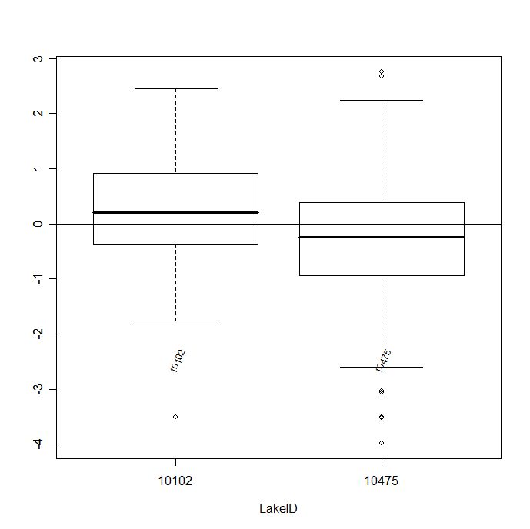

Plot of Tadpole Weight by Density, not separated by lake

